Day 21 – 26/07/2025

// Task001 and Task002: implementation of Liskov  
  
package Day21.Bird;  
  
public class Bird {  
 public static void main(String[] args) {  
 FlyingBirds eagle = new Eagle();  
 NonFlyingBirds emu = new Ostrich();  
 eagle.fly();  
 emu.speciality();  
 }  
}

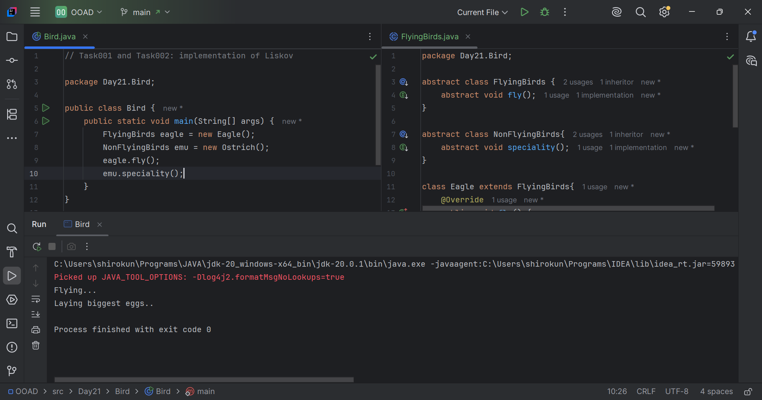

// Task003 and Task004: ISP implementation  
  
package Day21.Shapes;  
  
public class Shapes {  
 public static void main(String[] args) {  
 Circle circle = new Circle(7);  
 Sphere sphere = new Sphere(7);  
 System.*out*.println("Area of the given circle: "+circle.calcArea());  
 System.*out*.println("Perimeter of the given circle: "+circle.calcPeri());  
 System.*out*.println("Volume of the given sphere: "+sphere.calcVolume());  
 System.*out*.println("Area of the given sphere: "+sphere.calcArea());  
 System.*out*.println("Perimeter of the given sphere: "+sphere.calcPeri());  
 System.*out*.println();  
  
 }  
}

